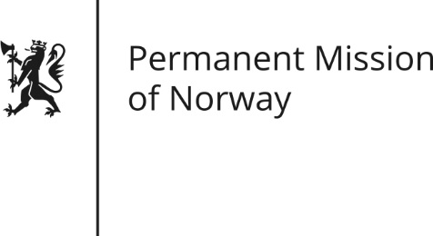

STATEMENT

Universal Periodic Review of Papua New Guinea, 6 May 2016

Statement by Thea Røkke

Check against delivery

Mr. President,

Norway welcomes the delegation from Papua New Guinea. Norway acknowledges PNG’s efforts to improve the country’s human rights situation since their last UPR.

Norway gives high priority to the global fight against the death penalty, which is an integral part of Norwegian human rights policy. Norway recommends Papua New Guinea to repeal all provisions in domestic law allowing for the death penalty, and to establish an official moratorium on executions with a view to abolishing the death penalty. Furthermore, Norway recommends commuting all death sentences to terms of imprisonment.

Gender equality is one of the most effective drivers of economic development, fair distribution, peace and democracy. To this end, Norway recommends Papua New Guinea to repeal any remaining laws and regulations that discriminate against women and girls, and to ensure that these laws are in compliance with human rights obligations and commitments. Furthermore, Norway recommends that PNG fully and promptly implements the Family Protection Act. Norway also recommends that PNG take steps to investigate all reports of gender-based violence, including accusations of sorcery, that perpetrators are brought to justice in fair trials, and that victims receive reparation and are given access to healthcare and other relevant services.

Finally, the practice of illegal logging and land grabbing represents a challenge both to the environment, and to the customary rights of landowners. Norway therefore recommends that the government take appropriate measures to prevent land grabbing and illegal logging and ensure that future actions are based on a respect for fundamental human rights and environmental protection.

Thank you

(257 ord)

